Ideation Phase
Define the Problem Statements

Date | 01 NOV 2025
Team ID | NM2025TMID02455
Project Name | Medical Inventory Managemen
Maximum Marks | 2 Marks

Customer Problem Statement Template:
Customers face challenges managing medical inventory due to inaccurate stock tracking, missing supplies, or expired items. This leads to delays in patient care, interrupted workflows, and difficulty maintaining compliance with safety standards. Staff often struggle to identify available stock or items nearing expiry, increasing the risk of errors and confusion.

They need a system that provides real-time inventory updates, automated alerts for low or expired stock, and controlled access to critical data. Features like notifications for replenishment and automated reordering would prevent shortages, ensure reliable supply management, and improve overall operational efficiency and staff confidence.

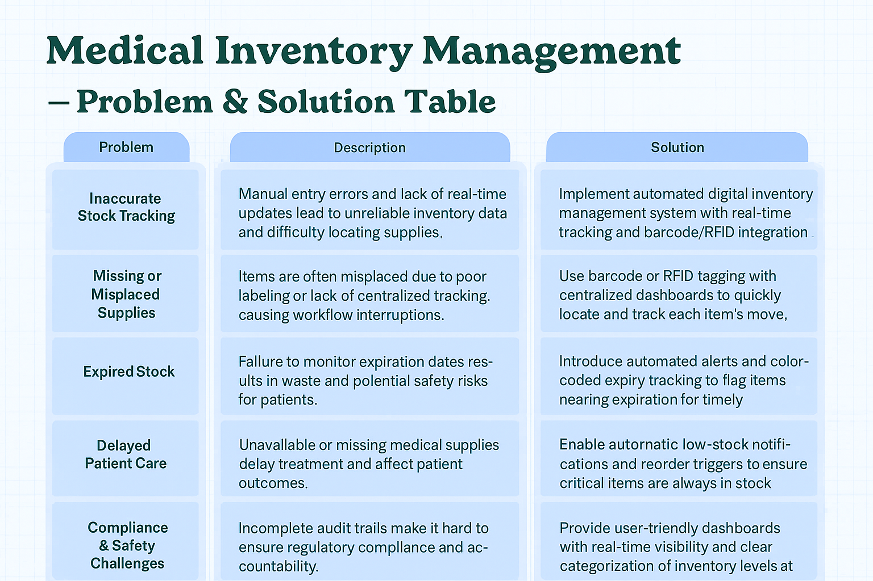

Example:

Problem  Statement (PS) | I am  (Customer) | I’m trying to | But | Because | Which makes me feel
PS-1 | A Pharmacist | Check available medicines | The stock count is often inaccurate | Inventory isn’t updated in real-time | Frustrated and unsure about supply accuracy
PS-2 |  | Locate a medical item quickly | I can’t find it in the system | Items are misplaced or not properly labeled | Stressed and delayed in patient care
  A Nurse

Problem Statement PS 1:
As a pharmacist, I am trying to check and update the available stock of medicines, but the system often shows inaccurate quantities because inventory data isn’t updated in real-time.
This limitation makes me feel frustrated and uncertain, as I can’t rely on the system to confirm which medicines are in stock or nearing expiry.
It leads to delays in dispensing medication and increases the risk of stockouts during busy periods. I need an automated, real-time tracking system that accurately updates stock levels as soon as medicines are dispensed or restocked.
Problem Statement PS 2:
As a nurse, I want to quickly locate and access specific medical supplies during patient care, but the system doesn’t clearly indicate where items are stored or if they are expired.
This causes confusion and delays when attending to patients, especially in emergencies.
It makes me feel stressed and anxious, knowing that I might be using outdated or missing supplies. I need a smart inventory system with clear labeling, real-time location tracking, and expiry alerts to ensure safety and efficiency in patient care.

